

**UNIVERSITY OF PETROLEUM & ENERGY STUDIES**

**Dehradun**

**CONTINOUS INTEGRATION**

**AND**

**CONTINOUS DELIVERY**

**Assignment 2**

**Name: Abhishek Singh**

**Course: B. TECH CSE DevOps (2018-22)**

**Roll no.: R171218120**

**Sapid: 500067726**

**Experiment-11**

**Step 1:- Create a Maven project using Eclipse**

**Project name: Abhishek**

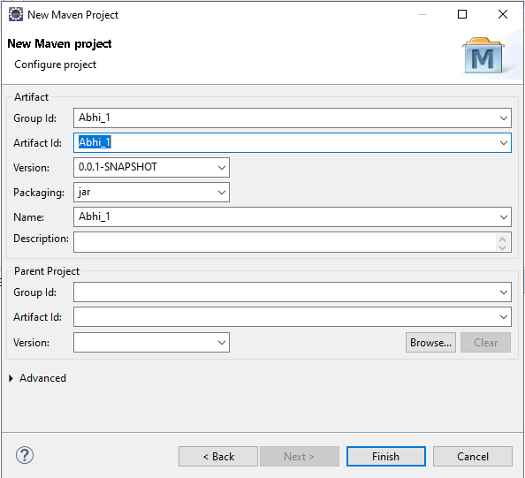

**Configure pom.xml by adding these dependencies**

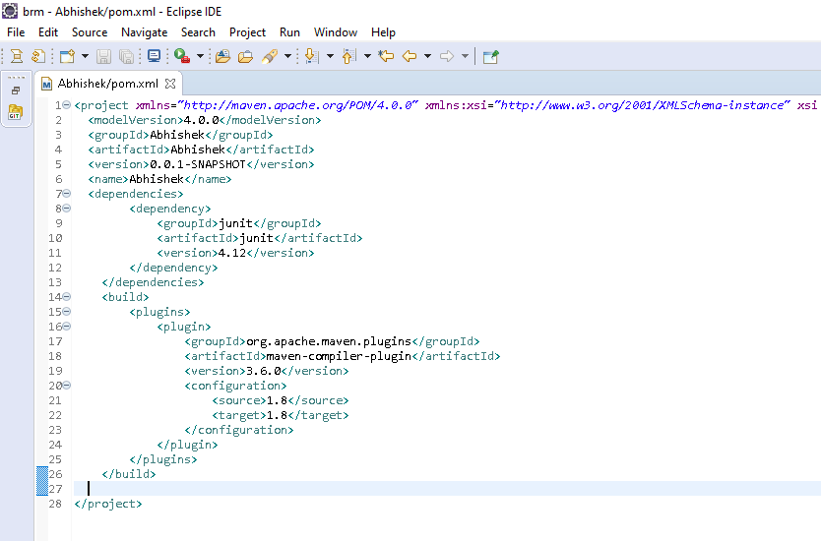

**Step 2:- Create a repository on github**

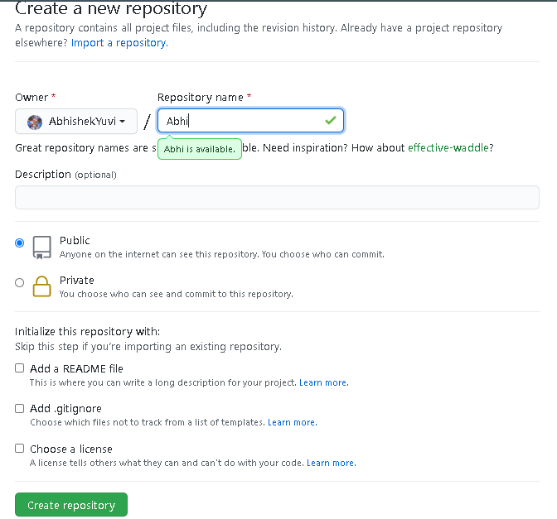

**Step 3:- Clone the repository that we have created on github and push the eclipse project through this repository**

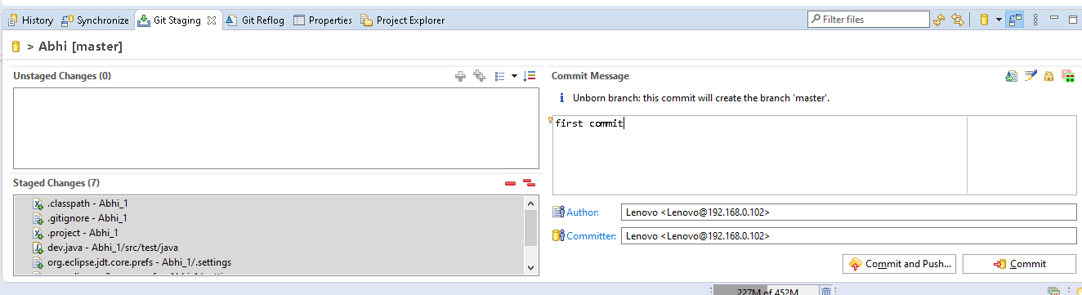

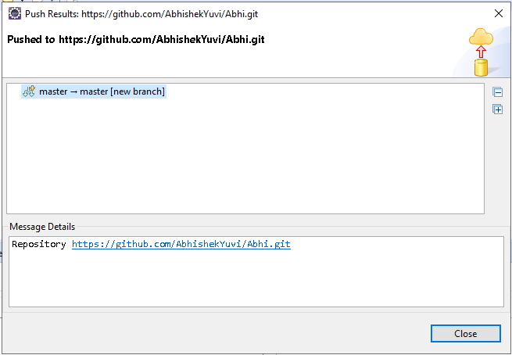

**Now refresh the github repository (Abhi) window, commits will appear on the github**

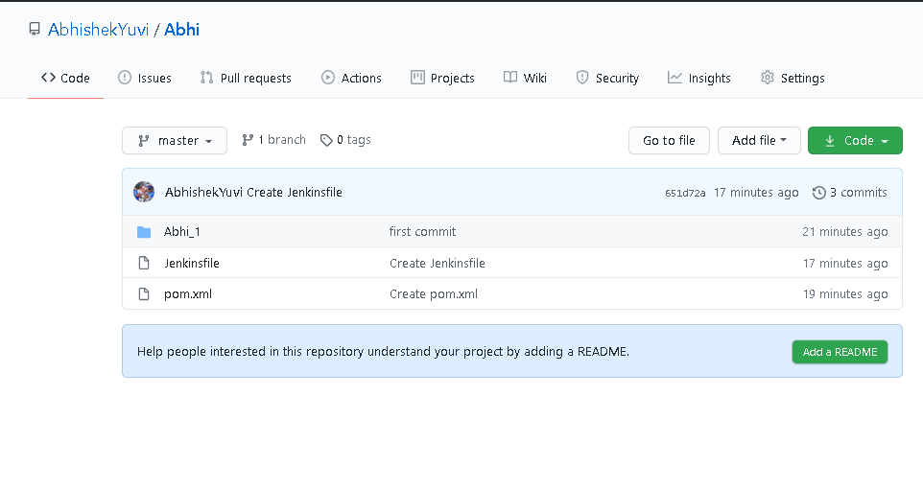

**Step 4:- Create a pipeline and configure it.**

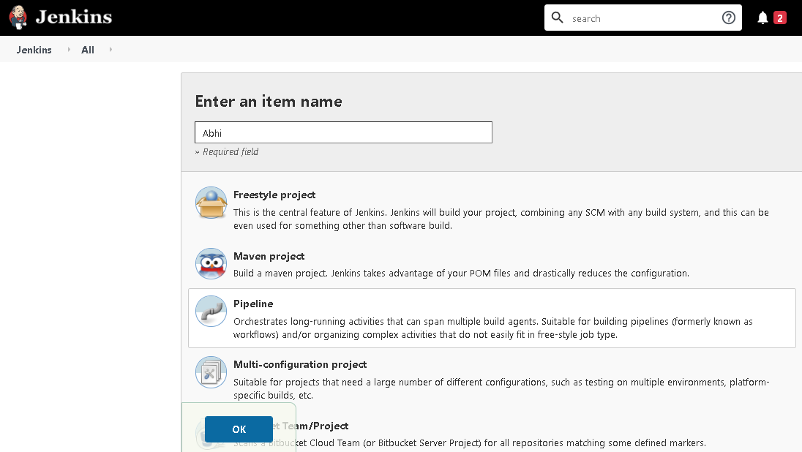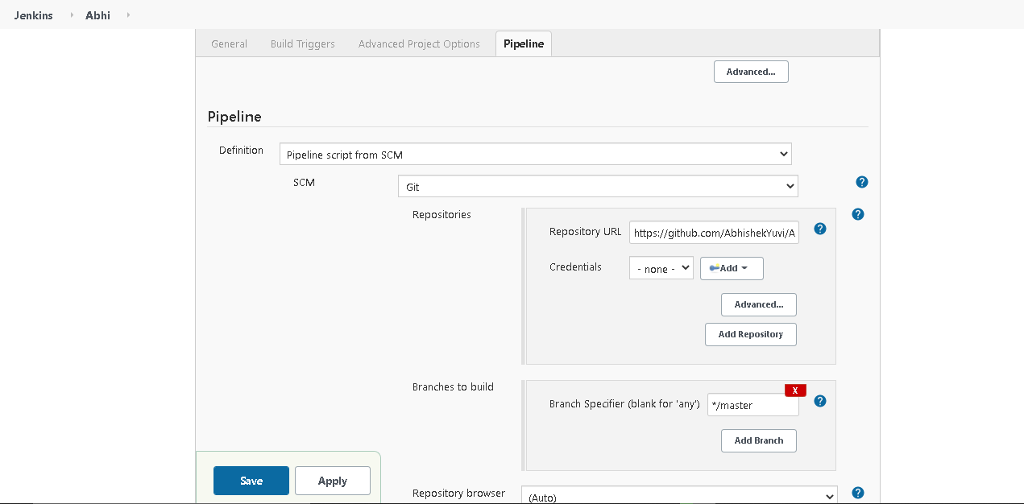

**Step 5:- Build the project**

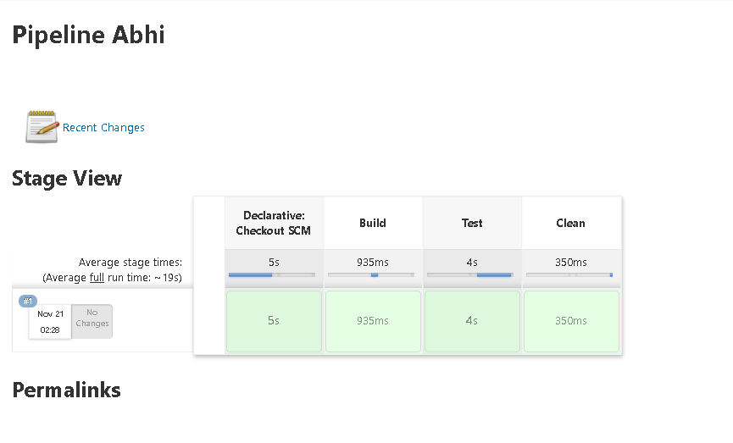

**Step 6:- Create a repository on Nexus**

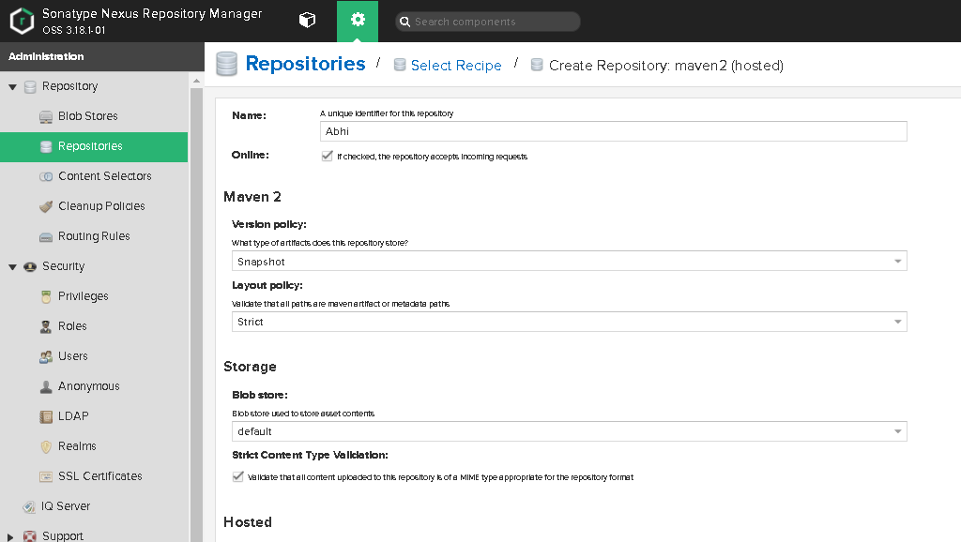

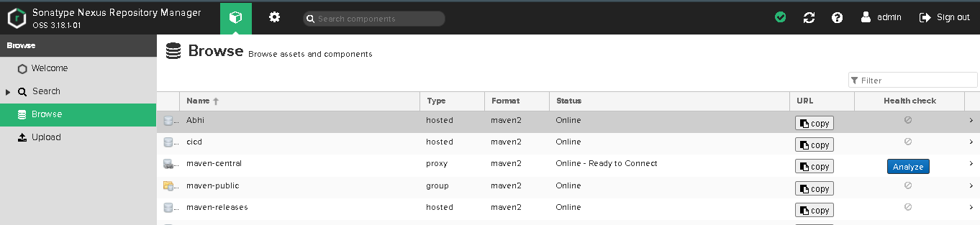

**Step 7:- through cmd enter into the maven project folder and run following maven commands**

**Mvn clean:**

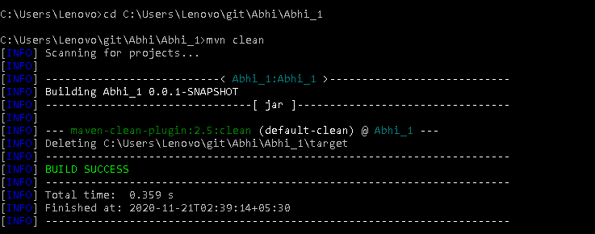

**Mvn install :**

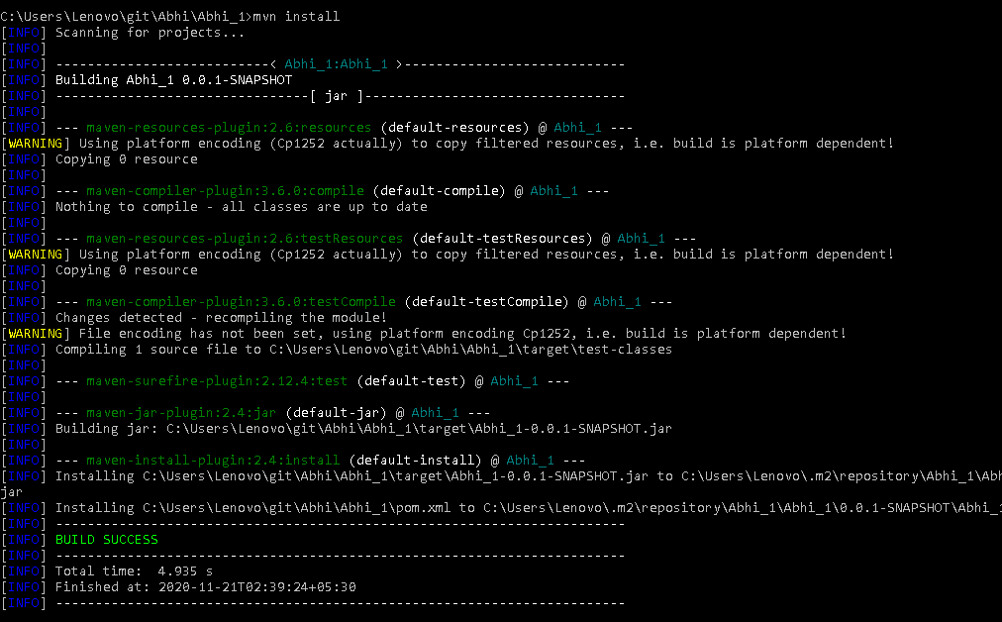

**Mvn deploy:**

